Follow these instructions for completing
- Do all work in Excel. Do not submit Word files or *.pdf files.
- Submit a single spreadsheet file for this assignment. Do not submit multiple files.
- Place each problem on a separate spreadsheet tab.
- Label all inputs and outputs and highlight your final answer.
- Follow the directions in “Guidelines for Developing Spreadsheets.”

P3–3 Income statement preparation On December 31, 2015, Cathy Chen, a self-employed
certified public accountant (CPA), completed her first full year in business. During
the year, she billed $360,000 for her accounting services. She had two employees, a
bookkeeper and a clerical assistant. In addition to her monthly salary of $8,000,
Ms. Chen paid annual salaries of $48,000 and $36,000 to the bookkeeper and the
clerical assistant, respectively. Employment taxes and benefit costs for Ms. Chen and
her employees totaled $34,600 for the year. Expenses for office supplies, including
postage, totaled $10,400 for the year. In addition, Ms. Chen spent $17,000 during
the year on tax-deductible travel and entertainment associated with client visits
and new business development. Lease payments for the office space rented (a taxdeductible
expense) were $2,700 per month. Depreciation expense on the office
furniture and fixtures was $15,600 for the year. During the year, Ms. Chen paid
interest of $15,000 on the $120,000 borrowed to start the business. She paid an
average tax rate of 30% during 2015.
a. Prepare an income statement for Cathy Chen, CPA, for the year ended December
31, 2015.
b. Evaluate her 2015 financial performance.

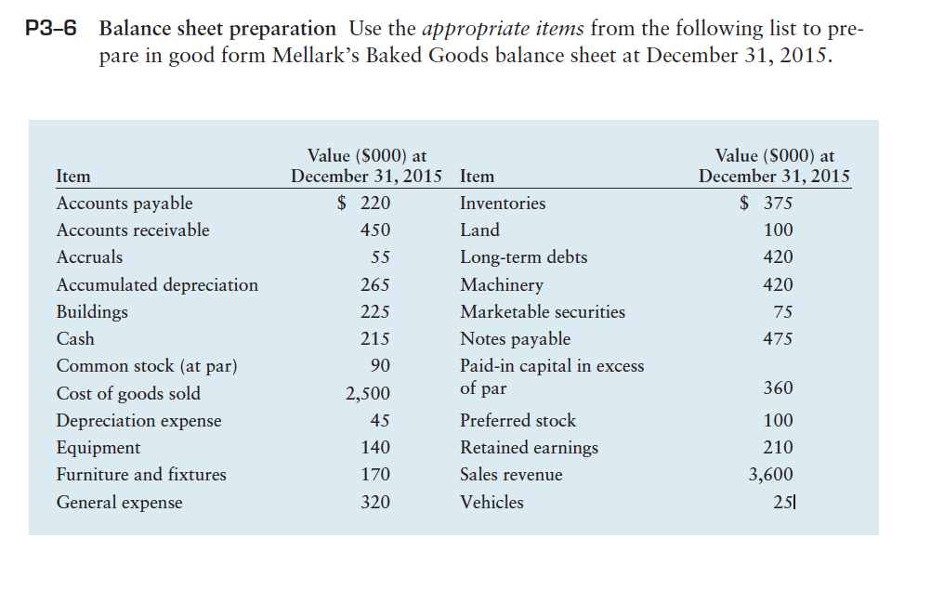

P3–10 Statement of retained earnings Hayes Enterprises began 2015 with a retained earnings
balance of $928,000. During 2015, the firm earned $377,000 after taxes. From
this amount, preferred stockholders were paid $47,000 in dividends. At year-end
2015, the firm’s retained earnings totaled $1,048,000. The firm had 140,000 shares
of common stock outstanding during 2015.
a. Prepare a statement of retained earnings for the year ended December 31, 2015,
for Hayes Enterprises. (Note: Be sure to calculate and include the amount of cash
dividends paid in 2015.)
b. Calculate the firm’s 2015 earnings per share (EPS).
c. How large a per-share cash dividend did the firm pay on common stock during
2015?

